ANNEX I
TUPAD PAYROLL TEMPLATE UNDER ACCREDITED CO-PARTNER
Republic of the Philippines
DEPARTMENT OF LABOR AND EMPLOYMENT
Regional Office No. _____

Province: __________________________________
Municipality: ________________________________
Barangay: ___________________________________

We hereby acknowledge to have received from _______ the sum specified opposite our respective names as full compensation for our services for the period __________________ to __________________.
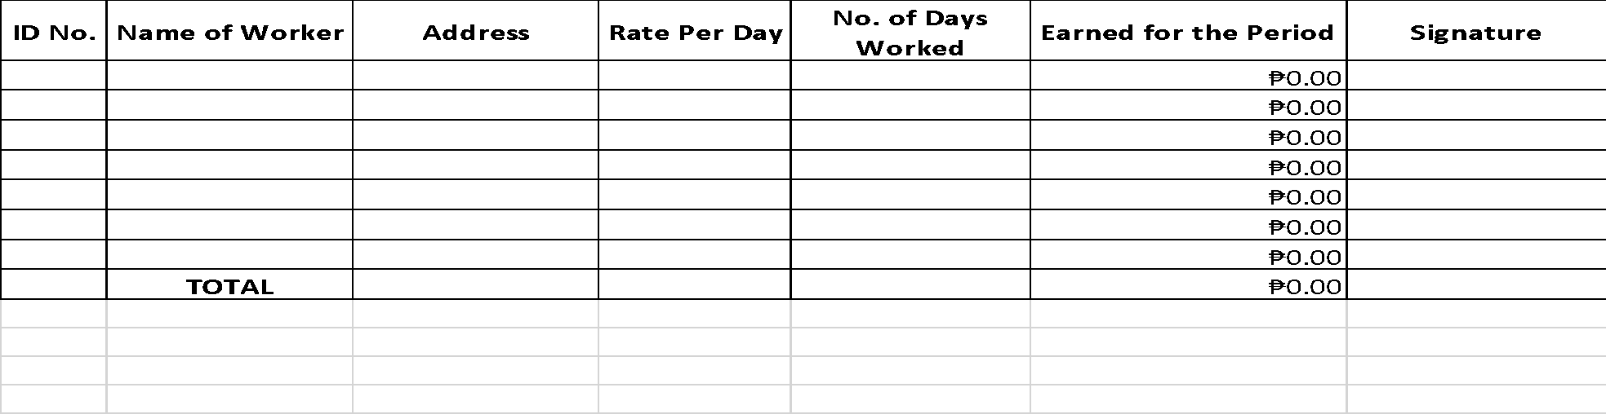

Funds Available: _________________________
Chief Accountant

- I CERTIFY on my official oath that the above 3. I CERTIFY on my official oath that I have paid to each
Payroll is correct and that the services have worker whose names appear above the
been duly rendered. amount set opposite their names.

_______________________________ _______________________________
LGU/ACP Focal Person Cashier/Treasurer

2. Approved payable from appropriation. 4. I CERTIFY on my official oath that I witness payment of salaries to workers.

_______________________________ _____________________________________
LCE/ACP Head DOLE PO/FO

